A List of Components

Adder

(Complicated Adder)
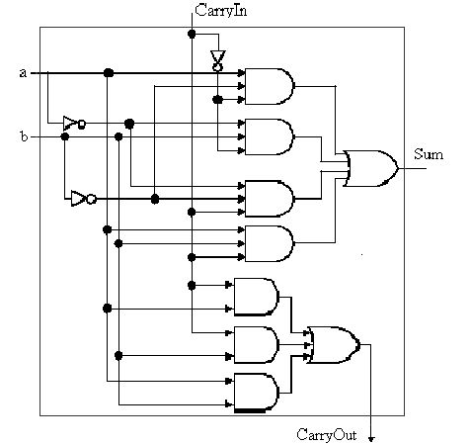
\

1. AND gate (x7)
2. OR gate (x2)
3. Inverter (x3)

(NOR logic)
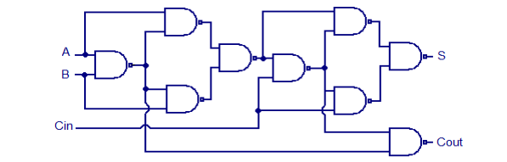

1. NOR gate (x9)

(XOR logic)
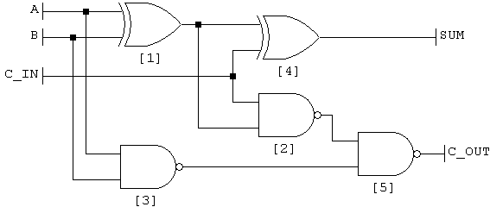

1. XOR gate (x2)
2. NAND gate (x3)

x to n Decoder

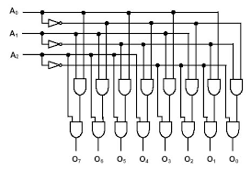

1. x inverters
2. 2n and gates
(control lines?)

2^n to n Multiplexor

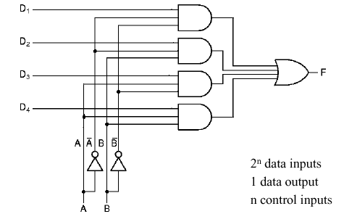

1. n to 2^n decoder
2. n AND gates
3. 1 OR gate
(control lines?)
1 bit MIPS ALU

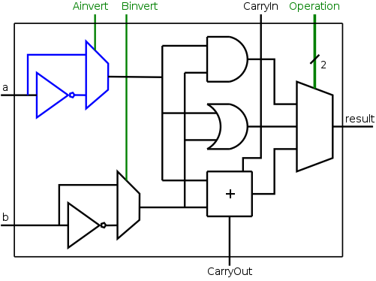

1. Inverter (x2)
2. 1-2 Multiplexor (x2)
3. Adder (x1)
4. AND gate (x1)
5. OR gate (x1)
6. 2-4 Multiplexor (x1)
(control lines)
32-bit MIPS ALU

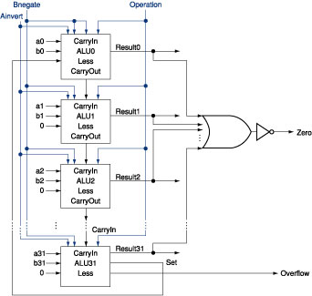

1. 1-bit MIPS ALU (x31)
2. 1-bit MIPS ALU with
overflow detection and
set output (x1)
3. OR gate (x1)
4. inverter (x1)
32-bit Register

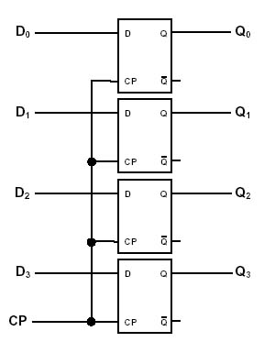

1. Edge-triggered
Flip-flop (x32)
2^n-Register File

1. Register (x 2^n)
2. n to 2^n
Decoder (x1)
3. n to 2^n
Multiplexor (x1)
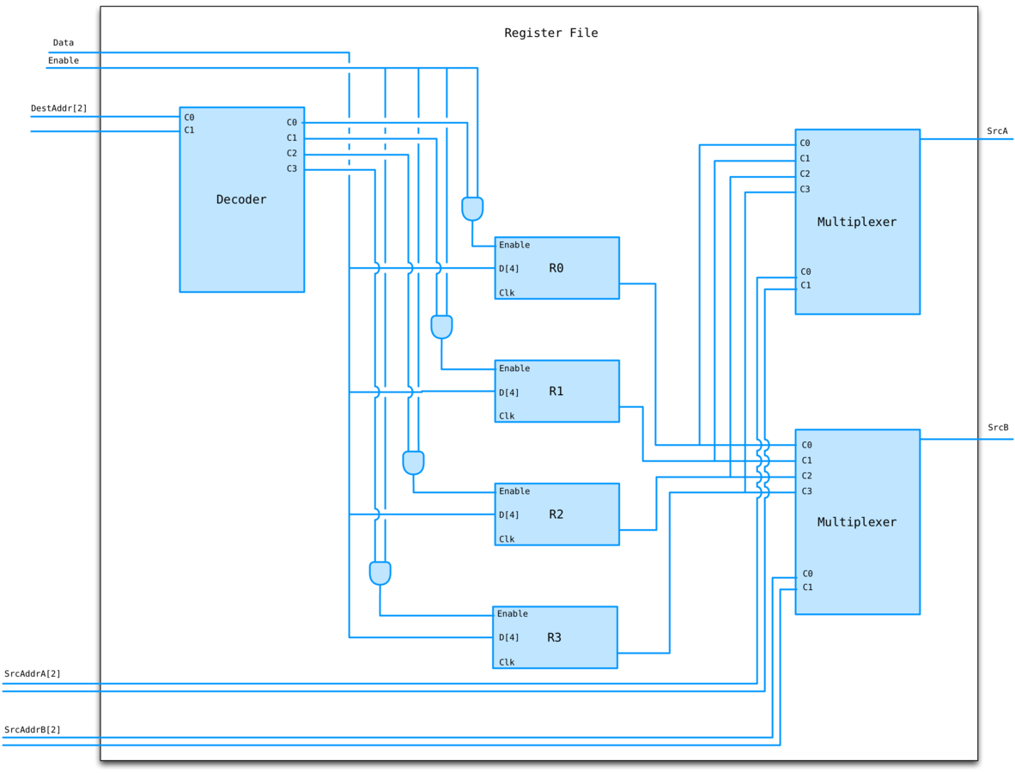
4. AND gate (x n)
Control Component

The truth table for the control component follows:

 | Signal Name: | R-format | lw | sw | beq
Inputs: | Op5 | 0 | 1 | 1 | 0
 | Op4 | 0 | 0 | 0 | 0
 | Op3 | 0 | 0 | 1 | 0
 | Op2 | 0 | 0 | 0 | 1
 | Op1 | 0 | 1 | 1 | 0
 | Op0 | 0 | 1 | 1 | 0
Outputs: | RegDest | 1 | 0 | X | X
 | ALUSrc | 0 | 1 | 1 | 0
 | MemToReg | 0 | 1 | X | X
 | RegWrite | 1 | 1 | 0 | 0
 | MemRead | 0 | 1 | 0 | 0
 | MemWrite | 0 | 0 | 1 | 0
 | Branch | 0 | 0 | 0 | 1
 | ALUOp1 | 1 | 0 | 0 | 0
 | ALUOp0 | 0 | 0 | 0 | 1

The following are boolean conjunctions for the Outputs in the above table:

RegDest = ¬Op0 · ¬Op1 · ¬Op2 · ¬Op3 · ¬Op4 · ¬Op5
AluSrc = Op0 · Op1 · ¬Op2 · ¬Op4 · Op5
MemToReg = Op0 · Op1 · ¬Op2 · ¬Op3 · ¬Op4 · Op5
RegWrite = ¬Op2 · ¬Op3 · ¬Op4
MemRead = Op0 · Op1 · ¬Op2 · ¬Op3 · ¬Op4 · Op5
MemWrite = Op0 · Op1 · ¬Op2 · Op3 · ¬Op4 · Op5
Branch = ¬Op0 · ¬Op1 · Op2 · ¬Op3 · ¬Op4 · ¬Op5
ALUOp1 = ¬Op0 · ¬Op1 · ¬Op2 · ¬Op3 · ¬Op4 · ¬Op5
ALUOp0 = ¬Op0 · ¬Op1 · Op2 · ¬Op3 · ¬Op4 · ¬Op5

It is helpful to notice here the following equivalences:
- RegDest = ALUOp1
- Branch = ALUOp0
- MemToReg = MemRead

Control Component (Cont'd)

In the following diagram, the following conjunctions were “anded” together to simplify the diagram by reducing the number of wires drawn:
- ¬Op0 · ¬Op1
- Op0 · Op1
- ¬Op2 · ¬Op3 · ¬Op4
- ¬Op2 · ¬Op4

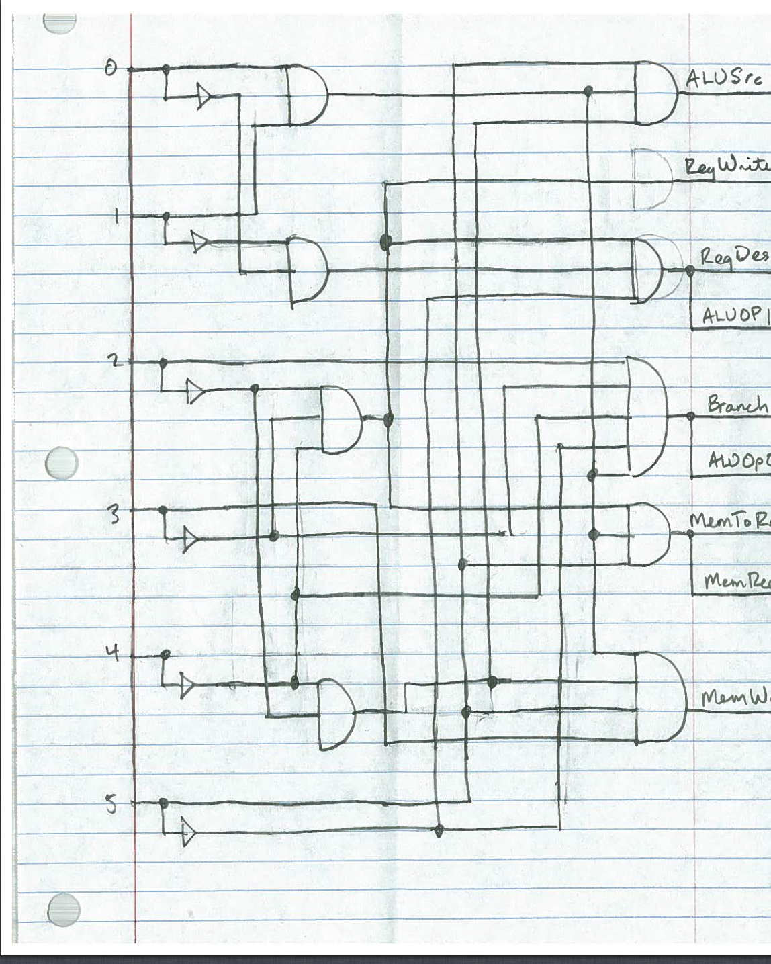

D Flip-Flop

1. D Latch (x2, i.e. - slave and master)
(Wires)

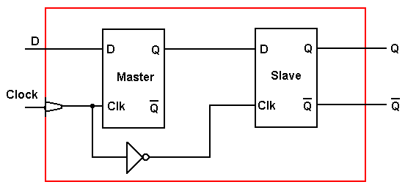

D Latch

1. AND Gate (x 2)
2. OR Gate (x2)
3. Inverter (x2)
(Wires)

